Yelp Restaurant Reviews dataset (also contains multi-table relationship between restaurant health violations and reviews) https://www.drivendata.org/competitions/5/keeping-it-fresh-predict-restaurant-inspections/page/33/
Extremely large dataset.
Target variable: number of restaurant violations
Direct variables: City, State, Postal Code, Rating, Review Count, Open/Closed, Hours
Indirect variables: Number of reviews of restaurant by users with high number of fans, Number of reviews of restaurant by users with low number of average stars, Number of check-ins on a business, Change in number of reviews before/after the violation, Change in number of stars before/after the violation, Business categories
Just looked at GPT 4o to get a sense of what variables it might create that look interesting:
- Popularity index (average of review count, check in count, compliment count)
- Rating consistency (standard deviation of stars over time)
- Peak hours of business
- Customer engagement index
- Average length of reviews
- Seasonal check-in pattern
- Business longevity
Dog adoption datasets (can join on animal ID w/ the target variable being adoption)
https://data.austintexas.gov/Health-and-Community-Services/Austin-Animal-Center-Outcomes/9t4d-g238/about_data
https://data.austintexas.gov/Health-and-Community-Services/Austin-Animal-Center-Intakes/wter-evkm/about_data
Target variable: outcome (adoption)
Direct variables: Animal Type, Hour, Month, Name, Age, Breed, Color
Indirect variables: Time of day (early, afternoon, evening), Season (spring, summer, fall, winter) of intake/out-take, Time between intake/out-take, Names that start with a specific letter, Combos of breed/color/age, Found location (in Austin or outside Austin)
Library checkout dataset (can join on title w/ target variable being whether a title was checked out)
https://data.seattle.gov/Community/Library-Collection-Inventory/6vkj-f5xf/about_data
https://data.seattle.gov/Community/Checkouts-by-Title/tmmm-ytt6/about_data
Target variable: Popular items (as defined as a checkout number greater than 100 or more), # checkouts per book/user
Direct variables: Title, Creator, Publisher, Publication Year, Physical/Digital, Item Location, Item Count, Item Collection
Indirect variables: Subjects, Number of Subjects, Author Popularity (as defined as an author writing 3 or more books held in the library), Subject Popularity (as defined as a subject having 100+ items), whether the title contains some word or some letter
GDP dataset
Target variable: GDP
Direct variable: each column originally in the dataset
Indirect variable: health expenditure per population, education expenditure per population, homicides per population, percent of migrants that make up total population, differences in employment between males and females for each sector

SAT dataset (join on school ID):
https://data.cityofnewyork.us/Education/2012-SAT-Results/f9bf-2cp4/about_data
https://data.cityofnewyork.us/Education/2006-2012-School-Demographics-and-Accountability-S/ihfw-zy9j/about_data
Target variable: SAT score (combined reading + math)
Direct variables: School, school year, total enrollment per school, English language learners percentage, number of test takers
Indirect variables: Number of grades offered in the school, ratio of males to females at the school, ratio of students of color to white students at the school, number of upperclassmen, ratio of test takers to upperclassmen

Correlations between two continuous variables: Pearson’s correlation coefficient
Correlations between categorical and continuous: One-way ANOVA
Correlations between two categorical variables: Chi squared test
---------------------
Direct correlations:
Created a csv file containing the monthly counts of the total number of shootings, shootings that were murders, shootings that were not murders, and shootings per borough. As each column represented a possible candidate for a correlation, this represented my direct candidates. My target column was the number of gun-related murders per month column (‘Murder’).
The number of gun-related murders per month is highly correlated with:
- Number of shootings that were not murders per month
- Number of total shootings per month
- Number of shootings in Brooklyn, Queens, Manhattan, and Bronx per month
And is not correlated with:
- Number of shootings in Staten Island per month
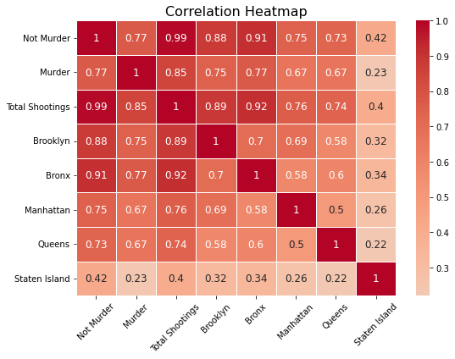
Indirect correlations:
Modified the original dataframe to create a csv file containing all shootings, as well as the race, age, and sex of the victims and race, age of the perpetrator. Other variables were included as well (time, precinct, etc.) The target variable remained the number of gun-related murders per month (‘Murder’).
Candidate variables would first have to be grouped by month (to have any meaningful comparison with the target variable) and then grouped by race, sex, etc. This would represent indirect candidates. Other indirect candidates could also be formed by combining variables (e.g. number of Black male victims per month, number of white female perpetrators per month).
All variables without “perp” in front of them refer to the victim. Each variable is measured in counts per month.
I didn’t analyze the latitude and longitude variables because I don’t know enough about NYC to determine exactly what the cutoffs should be, but that is something that we could group and one-hot encode.
Significant correlations:
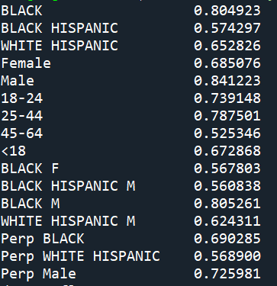
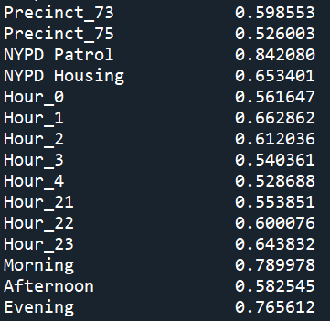
Insignificant correlations:
'Month'
'AMERICAN INDIAN/ALASKAN NATIVE'
'ASIAN / PACIFIC ISLANDER',
'UNKNOWN'
'WHITE'
'Unknown Gender'
'1022'
'65+'
'Unknown Age',
'BLACK HISPANIC F',
'BLACK U'
'UNKNOWN F'
'UNKNOWN M'
'UNKNOWN U'
‘WHITE F'
'WHITE HISPANIC F’
'WHITE M'
'Perp AMERICAN INDIAN/ALASKAN NATIVE'
'Perp ASIAN / PACIFIC ISLANDER'
'Perp BLACK HISPANIC',
'Perp UNKNOWN'
'Perp WHITE'
Perp Female'
'Perp Unknown Gender'
All other precincts
All other hours
NYPD Transit

LLM output:
Prompt: These two csv files contain a lot of interesting data. In the shootings1 csv file, there is a column titled "Murder" that counts up the number of gun-related murders per month in NYC. I want to know what variables in shootings1 and shootings2 are correlated with this "Murder" column. You can be creative in creating variables - you can combine variables, group variables by date, and more. I want these correlations to make sense given the target variable. Please find the candidate variables and run correlation analysis. Keep in mind that some variables are not numbers but strings that will need to be grouped and that other variables have null or NAN values.
ChatGPT (4o model): https://chatgpt.com/share/53fc43d1-d1d8-4f56-b243-808ade03f81e
- Did well with analyzing the direct correlations
- Came up with good ideas for analyzing the indirect correlations (perpetrator/victim characteristics per month, counts of incidents by precinct)
- Wasn’t able to actually combine the dataframes to do the indirect correlation analysis – it said there was a persistent NAN issue
  - Got very confused and tried to do a lot of different things before eventually giving up
  - Dataset did contain NAN values and (null) values but this could be cleaned up and did not affect my analysis
- Second time, the code written has the right idea but only looks at certain variables (“Black,” “male”) and may miss other important ones
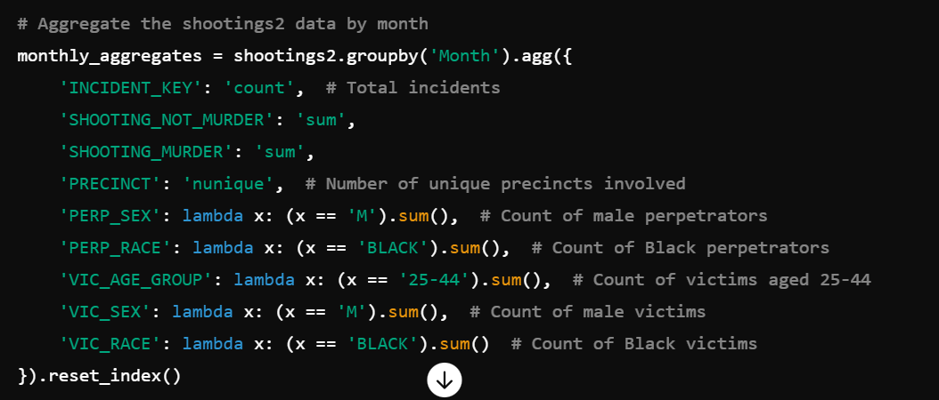
Copilot:
- Unable to analyze direct or indirect correlations due to an issue with merging the two dataframes (once again) – even after I say that merging is not possible due to a difference in the month columns
- Offers good ideas for potential correlates:
  - Date and time variables
  - Location variables (based on coordinates)
  - Demographic variables (race, sex)
  - Time of day, type of area variables (combo variables)
Julius:
- Correctly analyzes direct correlations
- Unable to analyze indirect correlations even after cleaning up NAN and null values… issue with merging the two dataframes leads to information being lost for the indirect columns, has trouble understanding that the different string values mean that each column cannot be considered its own variable
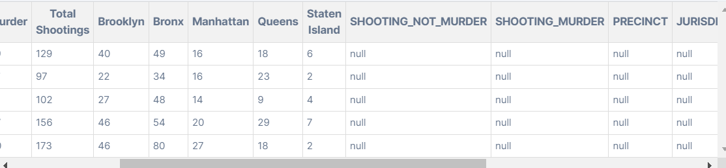
Dataset after merging – all indirect columns are now null.
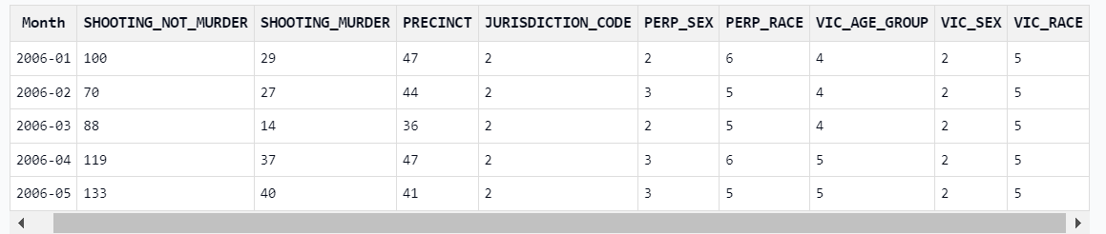
Unsure how the perp and victim columns’ data is being counted up, but this would not lead to meaningful correlations.
Databricks:
- Does not actually produce code but comes up with good variable candidates:
  - Time (month, hour)
  - Borough
  - Victim age, victim sex, victim race
  - Precinct, jurisdiction
- Doesn’t do any combos of victim age/sex/race
- Process for making these candidates (creating binary variables) makes sense (though doesn’t aggregate by month), perhaps because this is a SQL driven assistant and it knows how to handle situations like this

